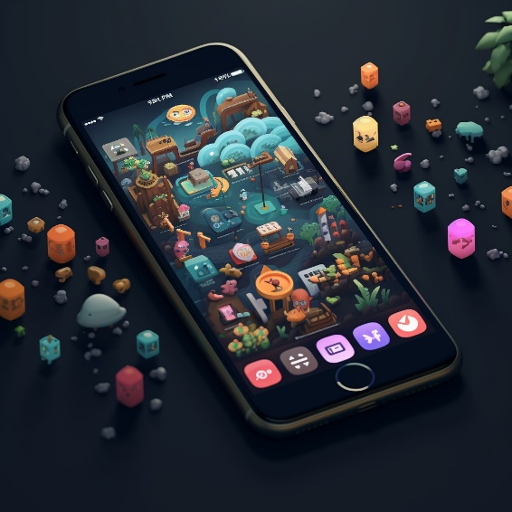

BINV2120-1

BURNY Pauline

Léonard De Vinci University-College Faculty of Science and Technology

*UNIT 2: Mobile applications*

# UNIT 2.1: Mobile applications

🧠 Brainstorming: Mobile Apps

1. What are your favourite mobile apps that you use regularly? (Give 5)
2. Do you prefer using native apps or web apps? Why?
3. Have you ever used a hybrid app? If yes, what was your experience like?
4. What features do you consider essential in a mobile app?
5. Are there any mobile apps that you couldn't live without?
6. Do you think the user interface and design of a mobile app influence your decision to use it?
7. Have you ever developed your own mobile app or been involved in the development process?
8. What's the most innovative mobile app you've come across recently?
9. How do you discover new mobile apps to try out?
10. Do you prefer using mobile apps that offer dark mode or light mode?
11. Have you ever deleted a mobile app because of poor performance or user experience?
12. What mobile app do you think has the best user onboarding experience?
13. Are there any specific types of mobile apps you wish existed but haven't found yet?
14. Do you use any mobile apps to stay organized or manage your daily tasks?
15. Have you ever used augmented reality (AR) or virtual reality (VR) apps? What was your impression?
16. How do you feel about the permissions that mobile apps request, such as access to your location or camera?
17. Do you prefer mobile apps that offer a lot of customization or ones that are simple and easy to use?
18. Have you ever switched from using a native app to a web app (or vice versa) for a specific task? Why?
19. What mobile app do you use for entertainment purposes (games, streaming, etc.)?
20. Do you think mobile apps have significantly changed the way you accomplish tasks in your daily life?

Vocabulary: Mobile applications

1. API (Application Programming Interface)
2. Hybrid App
3. Responsive Design
4. Native App
5. Mobile App
6. User Experience (UX)
7. Web App
8. App Store
9. Cross-Platform Development
10. URL (Uniform Resource Locator)

|  |  |
| --- | --- |
| An address used to access resources on the internet, typically used to locate web pages, documents, images, and other files. |  |
| A software application designed specifically for a particular mobile operating system (e.g., iOS or Android) using the programming languages and tools supported by that platform. |  |
| A type of application that can be accessed through a web browser and does not require installation on a device. It uses web technologies such as HTML, CSS, and JavaScript. |  |
| A single codebase that is used to develop applications for multiple platforms (e.g., iOS, Android, and web). It reduces development time and effort by sharing code across platforms. |  |
| The visual and functional quality of a user's interaction with an application, focusing on factors such as ease of use, accessibility, and overall satisfaction. |  |
| A platform-specific digital distribution service that allows users to search, download, and install applications onto their devices. |  |
| A software application that is developed using web technologies (HTML, CSS, JavaScript) and then wrapped within a native container for distribution on app stores. |  |
| A web development approach that ensures websites and applications adapt to different screen sizes and devices, providing an optimal viewing experience. |  |
| A set of rules and protocols that allows different software applications to communicate with each other and exchange data. |  |
| A standalone software application designed to run on a mobile device, offering functionality tailored to the device's capabilities and user experience. |  |

1. get the ball rolling
2. to drop the ball
3. on the same wavelength
4. hit the ground running
5. in the loop
6. In a nutshell
7. off the grid
8. on the cutting edge
9. back to the drawing board
10. up in the air

|  |  |
| --- | --- |
| Our team was ............................ when it came to the new app design, which made collaboration smooth and efficient. |  |
| We can't afford ................................. on this app launch; every detail needs to be perfect. |  |
| Keep me ............................. about any updates regarding the app's beta testing phase. |  |
| As soon as the app was released, it .............................. with thousands of downloads in the first week. |  |
| The initial user feedback wasn't as positive as we hoped, so we're going .................................. to make improvements. |  |
| ..................................., the app's main feature allows users to track their fitness progress and set goals. |  |
| Our developers are always striving to be .................................... of technology, ensuring our app remains competitive in the market. |  |
| Let's schedule a meeting to .............................. on the app's marketing campaign. |  |
| The release date for the app is still ............................., pending final approval from the QA team. |  |
| I'll be ............................... for a few days, so if you need anything related to the app, please reach out to my colleague. |  |

|  |  |
| --- | --- |
| 1. to log in | 1. 10. to opt out |
| 1. to check out | 1. to scroll through |
| 1. to sign up for | 1. to fill out |
| 1. to turn off | 1. to back up |
| 1. to ran into | 1. to opt in |
| 1. to set up | 1. to download |
| 1. to sync up | 1. to turn on |
| 1. to sign out | 1. to scroll down |
| 1. to update | 1. to opt out |
| 1. to log out | 1. to scroll through |

|  |  |
| --- | --- |
| Don't forget to .................... **to**the app using your username and password to access your account. |  |
| New users can .................... the app using their email address and creating a password. |  |
| I recommend you .................... the latest updates in the app's release notes. |  |
| Users have the option to .................... of receiving notifications if they prefer not to be alerted. |  |
| Follow the step-by-step guide to .................... your profile within the app. |  |
| Please .................... the feedback form to help us improve the app's user experience. |  |
| Make sure to ................... your data **with** the cloud to ensure your information is backed up. |  |
| To receive real-time notifications, remember to .................... the app's notification settings. |  |
| I .................... a minor bug while using the app; I'll report it to the support team. |  |
| Users can easily .................... the feed to view the latest updates and posts. |  |
| It's important to regularly .................... your data in case of device issues. |  |
| By .................... **to** location services, the app can provide personalized recommendations based on your location. |  |
| You can .................... the app from the App Store or Google Play. |  |
| Make sure to .................... the app to the latest version to access new features and improvements. |  |
| Plan an end time for your day, and ………………………….. of your computer at that time. |  |
| If you want to conserve battery, you can .................... certain app features when they're not in use. |  |
| To read the full article, .................... on the app's news section. |  |
| To ensure your account remains secure, always remember to .................... when using public computers. |  |

📖 Reading

**Native, Web, Hybrid, or Cross-Platform – How to Choose the Right Mobile App for Your Business?**

January 28 , 2023

Posted By: Neeraj Sharma

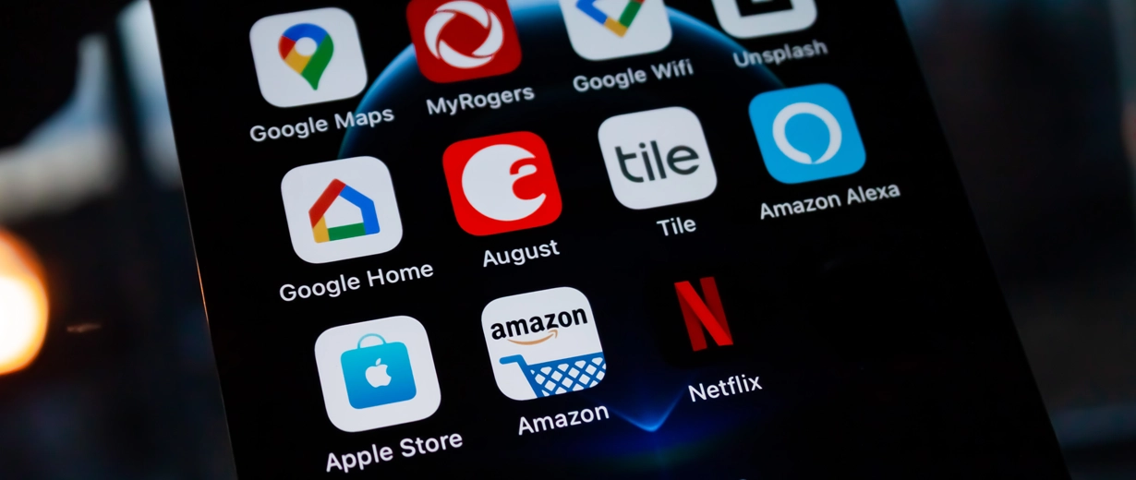

Ever since Google introduced the mobile-first indexing and mobile-friendly approach, Custom Mobile App Development has started gaining traction in the enterprise landscape. Companies are constantly on the lookout for cutting-edge mobile applications that can enable them to enhance customer experience and skyrocket business performance. The report by Allied Market Research Group predicts that the mobile application market will grow to reach $407.31 billion by 2026 at a CAGR of 18.4%.

Over the years, mobile devices and the applications that they have become more sophisticated, completely transforming the way we live and interact with our handheld mobile devices. Modern smartphones offer a wide range of functionality, such as allowing the users to access content on-the-go with the push of a button.

Mobile applications perfectly fit the bill for businesses looking to engage with their customers 24/7. Mobile apps also help brands develop a better understanding of their customers and plan their market strategies accordingly and build brand loyalty. However, getting a mobile application developed offers unique challenges for businesses, especially in choosing the type of mobile app that fits their specific use case and selecting the right Mobile App Development Services provider.

While looking for a suitable mobile app development partner, as a business owner, you’d often find yourself bombarded with a barrage of terminologies such as Native Apps, web apps, hybrid apps, and cross-platform apps. But how do you know which type of mobile application is best suited to your business needs? Although most of us are familiar with Android and iOS, it is critical to know the difference between native, web, hybrid, and cross-platform mobile apps.

**Types of Mobile Apps by Technology**

According to technology-wise categorization, mobile apps are of four broad types:

* Native Apps
* Web Apps
* Hybrid Apps
* Cross-Platform Apps
* Different Types of Mobile Apps for Business – What to Choose?
* Native Apps

Native mobile applications are written specifically for a platform or operating system such as Android or iOS using a native-to-the-operating system language. For example, to develop a native Android app, you need to write the code in Java or Kotlin; similarly, for the iOS native app, the code is written in Swift or Objective-C.

Pros:

* Native apps can extensively use the device’s hardware, such as the camera, GPS, microphone, compass, etc., and the operating system’s features.
* Native apps are highly performant, more reliable, more responsive, and deliver the ultimate user experience, which no other type of mobile app can match.
* Specifically developed for a platform with a singular focus, native apps are faster and more intuitive.
* Native apps leverage the device UI for delivering optimized customer experience.
* If your budget allows, native applications are the ideal choice.
* Native Mobile App Development is a future-proof investment

Cons:

* The primary disadvantage of choosing a native app is that it comes with a high upfront cost of development.
* Compared to other app types such as hybrid, web, or cross-platform, a native app has the highest cost of ownership.
* The prominent factor that drives up the developmental cost of a native app is that you need to write different code for each platform.
* The code written for the Android platform is unusable for the iOS operating system.
* You need to build and maintain different versions and codebases of the app.
* You need to hire different coders for each platform at extra cost.
* A native app is also not suitable for businesses looking to achieve faster time-to-market.
* Every time there’s an update, the user needs to download and reinstall the app.

Hybrid Apps

A hybrid app is a blend between a native app and a web application. In Hybrid Mobile App Development, the developers embed the mobile app’s code written in web development languages such as HTML5, CSS, and JavaScript into a native wrapper using plugins like Apache Cordova (Adobe PhoneGap) or Ionic’s Capacitor. Hybrid apps can download from app stores, just like native apps. Hybrid apps run from inside a native app and own embedded browsers using a WebKit such as WebView for Android and WKWebView for iOS.

Pros:

* A hybrid app is much quicker to develop and cost-effective when compared to a native app.
* A hybrid app can serve as a Minimum Viable Product (MVP) before a business decides to build a native application.
* Hybrid mobile app development is more streamlined.
* Hybrid apps load fast and are ideal for countries with slow internet connections.
* Hybrid apps deliver consistent user experiences.
* The code, once written, is usable for multiple platforms.
* Perfect for apps that provide content.
* Since hybrid apps use a single code base, there is less code to maintain.
* The plugin system helps the app to access the platform’s features.

Cons:

* Even though they look and feel like native apps, hybrid apps lack power and speed, considered as hallmarks of native apps.
* Achieving a great UX and navigation pattern is challenging in hybrid apps.
* Hybrid apps need to download various elements, which leads to higher load time.
* Hybrid apps can’t access all device features.

Cross-Platform Apps

Cross-platform apps are those which run on multiple platforms. They have a much broader scope than hybrid apps and serve as a mid-mile solution between a native app and a hybrid app. In the fast-changing business ecosystem, more and more companies are adopting the Bring Your Own Device (BYOD) model, wherein the employees bring their own devices to work, ushering the demand for cross-platform mobile development to customize applications for running on different devices. Many consider hybrid and cross-platform apps as the same, but in reality, the only common thing between them is code sharability. A bulk of cross-platform mobile app development involves building the app with web technologies such as JavaScript, HTML5, and CSS.

Pros:

* Developing A Cross-platform App requires less time in comparison to a native app.
* A single codebase is customizable for multiple platforms.
* Cross-platform apps deliver satisfactory performance and cross-platform support at an affordable cost.
* Cross-platform apps work well for games.
* Frameworks like React Native enable developers to build features like native UI, declarative programming, hot reloading, and modular architectures for a native-like app experience.

Cons:

* Debugging cross-platform apps takes much longer than native apps, even with the availability of frameworks like Xamarin.
* Even cross-platform apps require some platform-specific native development.
* Projects with complex code and third-party integrations increase development time and cost.
* Another significant risk is with cross-platform security threats designed to deliver malicious files to multiple platforms.

Web Apps

Mobile web app development involves leveraging web development languages such as HTML5, CSS, JavaScript, Ruby, etc., to build web applications that look and feel like native apps. Web apps are not standalone applications that need to be downloaded and installed on a mobile device. A web app is a responsive website that adapts itself to the user interface of the user’s device. When you install a web app, it merely bookmarks the URL on your device. Progressive Web App (PWA) is a kind of web app, which is a native app running inside a browser.

Pros:

* Cater to a broad customer base across geographies providing services across multiple device types.
* Web apps bridge together the resourcefulness of the internet and the functionality of touchscreens.
* A single version website helps improve SEO.
* Adaptive web applications scale and fit to different screen sizes from tablets to smartphones.
* There is no need to customize web-based apps for a specific platform or OS, which means lower development costs.
* Web apps don’t require space in your mobile device.
* Users don’t need to download or update a web app from the app store.

Cons:

* Web apps are entirely dependent on the browser used by the device, which means that the functionality supported by one browser might not be available in another browser.
* Since web apps are shells for websites, they can’t wholly work offline.
* Even if a web app has the option of offline mode, it still requires an internet connection to back up the data on the device, fetch new data, or refresh the screen.
* A web app may not always integrate with the device hardware.
* You can’t sell web apps through app stores.

**How Progressive Web Apps and AMP Pages Work Great Together?**

AMP stands for Accelerated Mobile Pages, which are stripped-down HTML copies of existing webpages that render quickly for static content. PWAs and AMP pages work great together to create compelling and super-fast user navigation. AMP pages can leverage many features of PWAs. The USP of AMP is the rapid delivery of content. Since a website’s Service Worker hinders the first load of PWAs, a good strategy is to have an AMP page as the entry point to your website and switch to the PWA for the onward journey. Re-using your AMP pages as data-source can dramatically reduce the complexities of backend development.

**How to Choose Just One?**

If you are looking to get a mobile app developed for your business, your choice of app type will depend on many factors. The following business needs should help you to choose the ideal mobile application.

**I Need a High-Performance Mobile App**

The bottom line is that in terms of performance, no other app type can match the native app experience. Next, in terms of performance, are cross-platform apps, hybrid apps, and web apps.

**I Need a Mobile App ASAP!**

If a faster time-to-market is on the top priority of your business plan, native mobile app development cannot be the ideal choice for you. You should invest in building a web app, which takes the least time to develop and deploy.

**I Have Limited Resources**

If budget limitations constrain your business, you must consider getting a web app or a hybrid app built. Although the benefits of native mobile app development far outweigh its development cost, a hybrid app can serve as an MVP for your business to test waters.

**My Business App Should Be Fast and Stable**

If performance and functionality are your top business priorities, there is no way around it. All you need is a native app, as it gives you speed, stability, and customization, which are crucial for your success.

**Questions :**

1. What are the key reasons behind the increased interest in Custom Mobile App Development in the enterprise landscape?

………………………………………………………………………………………………………………………………………………………………………………………………………………………………………………………………………………………………………………………………………………………………………………………………

1. According to the report by Allied Market Research Group, what is the projected size of the mobile application market by 2026?

………………………………………………………………………………………………………………………………………………………………………………………………………………………………………………………………………………………………………………………………………………………………………………………………

1. How have mobile devices and applications transformed our interaction with handheld devices over the years?

………………………………………………………………………………………………………………………………………………………………………………………………………………………………………………………………………………………………………………………………………………………………………………………………

1. What advantages do mobile applications offer to businesses seeking to engage with customers continuously?

………………………………………………………………………………………………………………………………………………………………………………………………………………………………………………………………………………………………………………………………………………………………………………………………

1. What challenges do businesses face when it comes to getting a mobile application developed?

………………………………………………………………………………………………………………………………………………………………………………………………………………………………………………………………………………………………………………………………………………………………………………………………

1. What are the primary types of mobile apps categorized by technology?

………………………………………………………………………………………………………………………………………………………………………………………………………………………………………………………………………………………………………………………………………………………………………………………………

1. What distinguishes native apps from other types of mobile apps in terms of their development approach?

………………………………………………………………………………………………………………………………………………………………………………………………………………………………………………………………………………………………………………………………………………………………………………………………

1. What are the advantages of native apps in terms of performance and user experience?

………………………………………………………………………………………………………………………………………………………………………………………………………………………………………………………………………………………………………………………………………………………………………………………………

1. What are the drawbacks of choosing a native app for mobile app development?

………………………………………………………………………………………………………………………………………………………………………………………………………………………………………………………………………………………………………………………………………………………………………………………………

1. How do hybrid apps combine elements of both native and web applications?

………………………………………………………………………………………………………………………………………………………………………………………………………………………………………………………………………………………………………………………………………………………………………………………………

1. What advantages does a hybrid app offer in terms of development speed and cost-effectiveness?

………………………………………………………………………………………………………………………………………………………………………………………………………………………………………………………………………………………………………………………………………………………………………………………………

1. What challenges might businesses encounter when aiming for a great user experience and navigation pattern in hybrid apps?

………………………………………………………………………………………………………………………………………………………………………………………………………………………………………………………………………………………………………………………………………………………………………………………………

1. What is the concept of Cross-Platform Apps, and how do they differ from hybrid apps?

………………………………………………………………………………………………………………………………………………………………………………………………………………………………………………………………………………………………………………………………………………………………………………………………

1. What are the benefits of developing cross-platform apps, and in what scenarios are they particularly useful?

………………………………………………………………………………………………………………………………………………………………………………………………………………………………………………………………………………………………………………………………………………………………………………………………

1. What considerations should businesses keep in mind when opting for web app development?

………………………………………………………………………………………………………………………………………………………………………………………………………………………………………………………………………………………………………………………………………………………………………………………………

1. What are Progressive Web Apps (PWAs), and how do they offer a unique combination of web and native app features?

………………………………………………………………………………………………………………………………………………………………………………………………………………………………………………………………………………………………………………………………………………………………………………………………

1. How can AMP Pages and PWAs complement each other to enhance user navigation and content delivery?

………………………………………………………………………………………………………………………………………………………………………………………………………………………………………………………………………………………………………………………………………………………………………………………………

1. When choosing a mobile app type for your business, what factors should you consider?

………………………………………………………………………………………………………………………………………………………………………………………………………………………………………………………………………………………………………………………………………………………………………………………………

1. If a high-performance mobile app is your priority, which app type would be the best choice? Why?

………………………………………………………………………………………………………………………………………………………………………………………………………………………………………………………………………………………………………………………………………………………………………………………………

1. What would you recommend to a business seeking a rapid time-to-market for their mobile app development?

………………………………………………………………………………………………………………………………………………………………………………………………………………………………………………………………………………………………………………………………………………………………………………………………

1. For a business with limited resources, which app types would you suggest as potential options?

………………………………………………………………………………………………………………………………………………………………………………………………………………………………………………………………………………………………………………………………………………………………………………………………

1. If a business's main focus is on having a fast and stable app, which type of app would you advise them to choose? Why?

………………………………………………………………………………………………………………………………………………………………………………………………………………………………………………………………………………………………………………………………………………………………………………………………

# ❤️ Theory: Mobile, Web or Native?

1. **Mobile Apps**

Mobile apps are applications designed specifically for **mobile devices** such as smartphones and tablets. They are installed directly onto the device through **app stores** (e.g., Apple App Store, Google Play Store) and are **optimized** to provide a seamless **user experience** on small screens and **touch interfaces**. Mobile apps can access device features like camera, GPS, and notifications.

*Example: Instagram's mobile app, which allows users to share photos and videos, interact with others, and explore content through a visually appealing interface.*

1. **Web Apps:**

Web apps are applications accessed through **web browsers** on various devices, including desktop computers, laptops, tablets, and smartphones. They are typically **responsive**, adapting to different screen sizes. Users don't need to install them; they can simply access them by entering a website's URL. Web apps are generally **platform-independent** and can be used across different operating systems.

*Example: Google Docs, a web-based word processing application that allows users to create, edit, and collaborate on documents online through their web browsers.*

1. **Native Apps:**

Native apps are applications developed specifically for a particular **operating system**, such as iOS or Android. They are written using **platform-specific** **programming languages** (Swift or Objective-C for iOS, Java or Kotlin for Android) and are optimized to take full advantage of the device's capabilities. Native apps offer the best **performance** and can work **offline**, but they require separate development efforts for different platforms.

*Example: WhatsApp, a messaging app that offers a highly integrated and efficient user experience by utilizing the native capabilities of the respective iOS and Android platforms.*

In summary, the key differences lie in their installation methods, compatibility, and development approach:

* Mobile apps are designed for mobile devices and installed from app stores.
* Web apps are accessed through web browsers and are platform-independent.
* Native apps are developed for specific platforms, offering optimized performance and access to device features, but requiring separate development for each platform.

Vocabulary :

Mobile Apps:

* Mobile devices: Devices like smartphones and tablets.
* App stores: Platforms like the Apple App Store and Google Play Store where users can download mobile apps.
* Optimized: Tailored or adjusted to work well in a specific context.
* User experience: The overall experience a user has while interacting with a product or service.
* Touch interfaces: Interfaces that respond to touch gestures like tapping and swiping.

Web Apps:

* Responsive: Able to adapt and function well on different screen sizes and devices.
* Platform-independent: Not tied to a specific operating system or device.
* URL: Uniform Resource Locator, the address used to access websites on the internet.

Native Apps:

* Operating system: The software that manages a device's hardware and provides a user interface.
* Platform-specific: Designed for a particular operating system or platform.
* Programming languages: Languages used to write code for software development.
* Performance: How well a software application functions in terms of speed and efficiency.